**Shift Microoperations**

**Shift microoperations are used for serial transfer of data. They are used in conjunction with arithmetic and logic operations. The contents of a register can be shifted to the left or the right. The first flipflop receives its binary information from the serial input.**

**During a shift left operation the serial input transfers a bit into the rightmost position.**

**During a shift right operation the serial input transfers a bit into the leftmost position.**

**The information transferred through the serial input determines the type of shift.**

**Types of Shift Microoperations**

**There are three types of shifts:**

**1. Logical shift 2. Circular shift 3. Arithmetic shift**

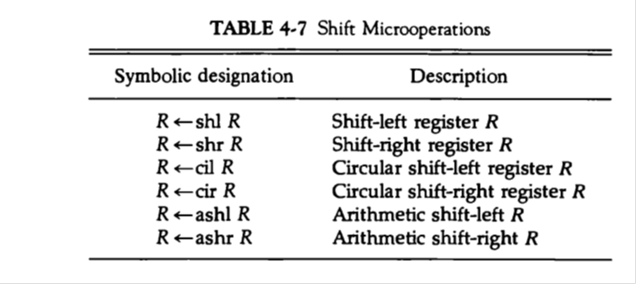

**1. Logical shift**

**A logical shift is one that transfers 0 through the serial input. Symbols used for logical shift left and logical shift right are shl and shr respectively.**

**Logical shift left(shl): shl R1 denotes 1-bit shift to the left of the content of register R1**

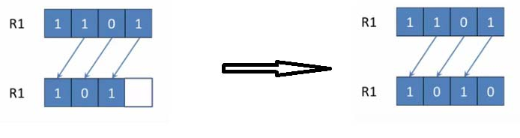

**The bit transferred to the end position through the serial input is assumed to be 0 during logical shift.**

**Logical shift right(shr): shl R1 denotes 1-bit shift to the right of the content of register R1**

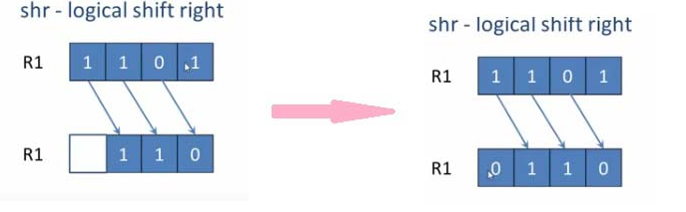

**2. Circular Shift**

**Circular shift also known as a rotate operation circulates the bits of registers around the two ends without loss of information.**

**This is accomplished by connecting the serial output of the shift register to its serial input.**

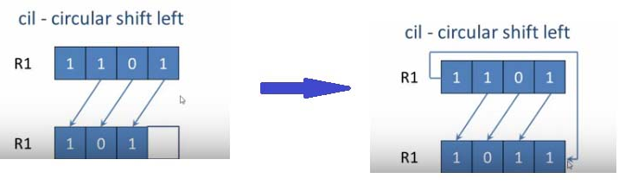

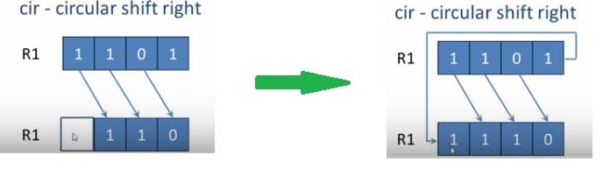

**3. Arithmetic shift**

**Arithmetic shift is a micro operation that shifts a signed binary number to the left or right.**

**An arithmetic shift-left multiplies a signed binary number by 2.**

**An arithmetic shift right divides the number by 2.**

**Arithmetic shifts must leave the sign bit unchanged because the sign of the number remains the same when it is multiplied or divided by 2.**

**The left most bit in a register holds the sign bit and remaining bits hold the number. The sign bit is 0 for positive and 1 for negative.**

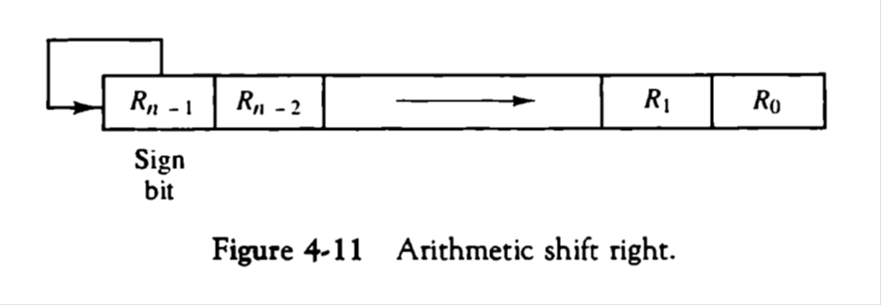

**Figure 4-11 shows a typical register of n bits. Bit Rn-1 in the left most position holds the sign bit. Rn-2 is the most significant bit of the number and R0 is the least significant bit.**

**The arithmetic shift-right leaves the sign bit unchanged and shifts the number to the right.**

**The arithmetic shift-left inserts a 0 into R0 and shifts all other bits to the left.**

